A000-Asia-Thailand-Ban Chiang-Bangles-Shell-3600 BCE

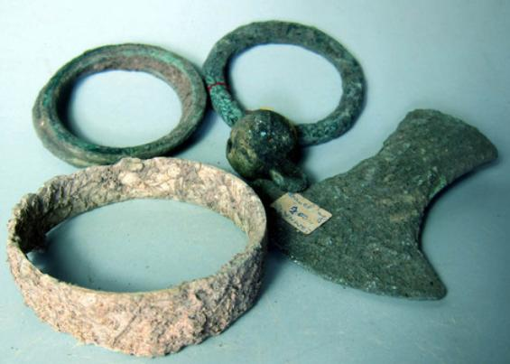

Fig. 1. Thailand-Ban Chiang-Bangles-Shell-3600 BCE

**Case no.: 5**

**Accession Number:**

**Formal Label:** Thailand-Ban Chiang-Bangles-Shell-3600 BCE

Case no.:

Accession Number:

Formal Label: Thailand-Ban Chiang-Bangles-Shell-3600 BCE

Display Description: This large Ban Chiang marine shell bangle may date to the Neolithic at Ban Chiang, c 3600 BCE. There were no associated bronze artifacts with this specimen but there were terra cotta objects such as bottles and utilitarian wares.

LC Classification: DS589.B17

Date or Time Horizon: 300 BCE-300 CE

Geographical Area: Ban Chiang, Udon Thani, Thailand

Map:

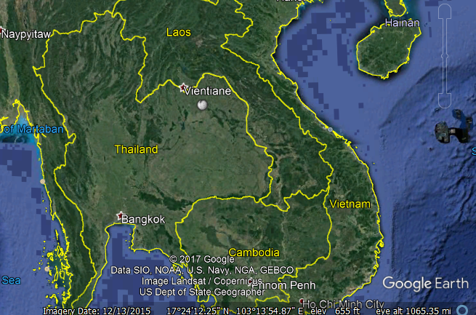

Fig. 4. Ban Chiang is near the white solid circular marker SE of Vientiane.

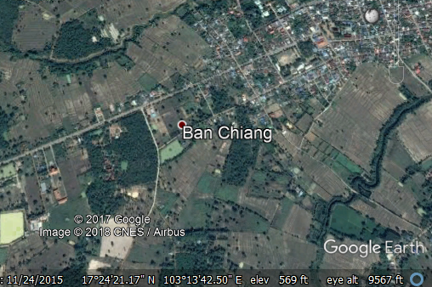

Fig. 6. Detail of Ban Chiang location.

GPS coordinates: [17°24′25″N 103°14′29″E](https://tools.wmflabs.org/geohack/geohack.php?pagename=Ban_Chiang&params=17.4069_N_103.2414_E_type:landmark_region:TH-41)

Cultural Affiliation: Ban Chiang

Medium: Shell

Dimensions:

Weight:

Condition: original

Provenance: Thailand

Discussion:

A date of 2100 BCE was obtained from rice phytoliths from inside a grave vessel of the lowest grave. A dating program for this site has involved dating the bones from the people who lived at Ban Chiang and the bones of animals interred with them. The resulting determinations have been analyzed using the Bayesian statistic OxCal 4.0, and the results suggested that the initial settlement of Ban Chiang took place by about 1500 BCE, with the transition to the Bronze Age about 1000 BCE (White 2008).

References:

Higham, Charles. 1998. *Prehistoric Thailand*. River Books; 1st Edition edition.

Higham C.F.W. and T.F.G. Higham 2009. “A new chronological framework for prehistoric Southeast Asia, based on a Bayesian model from Ban Non Wat,” *Antiquity* 82:1-20.

Higham C.F.W. 2011. The Bronze Age of Southeast Asia: new insight on social change from Ban Non Wat. *Cambridge Archaeological Journal* 21(3): 365-89

Higham C.F.W., R. Ciarla, T.F.G. Higham, A. Kijngam and F. Rispoli. 2011. “The establishment of the Bronze Age in Southeast Asia,” *Journal of World Prehistory* 24 (4),227-274:

Higham C.F.W., T.F.G. Higham and A. Kijngam. 2011. “Cutting a Gordian Knot: The Bronze Age of Southeast Asia, timing, origins and impact,” *Antiquity* 85:583-98.

Pietrusewsky, Michael; Douglas, Michele T. (Michele Toomay) 2001. ["Intensification of Agriculture at Ban Chiang: Is There Evidence from the Skeletons?"](http://muse.jhu.edu/login?uri=/journals/asian_perspectives/v040/40.2pietrusewsky.pdf) (PDF). [Asian Perspectives](https://en.wikipedia.org/wiki/Asian_Perspectives). [Project MUSE](https://en.wikipedia.org/wiki/Project_MUSE): [University of Hawai'i Press](https://en.wikipedia.org/wiki/University_of_Hawai%27i_Press). 40 (2): 157–178. [doi](https://en.wikipedia.org/wiki/Digital_object_identifier):[10.1353/asi.2001.0023](https://doi.org/10.1353%2Fasi.2001.0023). [eISSN](https://en.wikipedia.org/wiki/International_Standard_Serial_Number#Electronic_ISSN) [1535-8283](https://www.worldcat.org/issn/1535-8283). [ISSN](https://en.wikipedia.org/wiki/International_Standard_Serial_Number) [0066-8435](https://www.worldcat.org/issn/0066-8435)..

White, J.C. and Hamilton, E. G. 2009. “The Transmission of Early Bronze Technology to Thailand: New Perspectives,” *World Prehistory* 22: 357–397

White, J.C. 2008 “Dating Early Bronze at Ban Chiang, Thailand.” In *From Homo erectus to the Living Traditions*. Pautreau, J.-P.; Coupey, A.-S.; Zeitoun, V.; Rambault, E., editors. European Association of Southeast Asian Archaeologists, Chiang Mai, pp. 91-104.

White, J. C. 1995. “Incorporating Heterarchy into Theory on Socio‐political Development: The Case from Southeast Asia,” *Archeological Papers of the American Anthropological Association*, 6(1), 101-123.